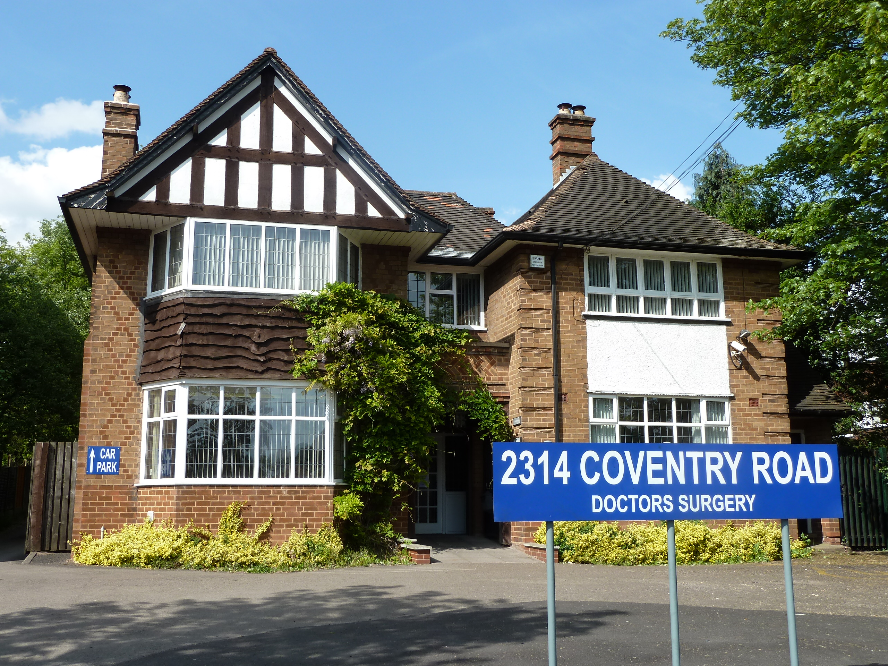 Coventry Road Practice – Statement of Purpose

Registered Provider

Coventry Road Practice  2314 Coventry Road  Sheldon  Birmingham B26 3JS  0121 743 2154  www.coventryroadpractice.co.uk | CQC Registration Date | : | 01/04/2013
 | Registered Provider | : | Coventry Road Practice
 | CQC Registered Manager | : | Dr Vino Ganespathy
 | CQC Service Provider ID | : | 1-199775510
 | Practice Manager | : | Tracey Cant
 | Email Contact | : | Tracey.cant@nhs.net

Coventry Road Practice is a partnership practice with approximately 4700 patients. It is a well established practice, conveniently located on the Coventry Road with plenty of local bus stops in the vicinity. It is a privately owned building with consulting and treatment rooms downstairs and upstairs. The practice has a front car park which is mainly used for elderly patients and we have a larger rear car park. We also have a parking space outside the practice which is reserved for patients displaying a disabled sticker. The surgery is accessible to patients using a wheelchair.

Inside the surgery we have a downstairs disabled toilet and if patients cannot use the stairs we arrange for patients to be seen downstairs.
Coventry Road Practice is working together with the North Solihull Collaborative (NSC) which is a group of 10 practices located in the North of Solihull to provide extended access services. This will provide pre-bookable appointments between the hours of 6.30pm – 8pm Mon – Fri and Saturday all day. The extended access hub will be located at Bosworth Medical Centre in Chelmsley Wood and Coventry Road Practice.
Aims and Objectives

To provide a high standard of care that fully satisfies the needs and expectations of our patients. Through consultation, examination and investigation we aim to deliver the most appropriate and effective care pathways and continuously strive for improvement through training, listening to our team and patient participation.
- Maximise accessibility and the range of services offered to meet the needs of all our patients
- Continuously review, develop and improve our services
- Understand the views of our patients, seeking guidance on the services we offer
- Provide a safe environment for both patients and staff.
- Maintain a stable, committed and well trained team of clinical and non-clinical staff.

Accessible Standards
If you have any problems with communication please let the surgery know. We aim to identify, record and meet your communication needs.
Our Team

Doctors | Nursing Team
- Dr Vino Ganespathy (GP Partner) | - Rebecca Cordon (Practice Nurse)
- Dr Chandni Deb-Dhillon (GP Partner) | - Nikki Wright (Practice Nurse)
- Dr Tim Badcock (Salaried GP) | - Angela McGarry (HCA)
- Dr Alison Portes (Salaried GP)

Admin & Reception Staff
- Tracey Cant (Practice Manager) | - Angela McGarry (Receptionist)
- Carol McAndrew (Secretary) | - Gemma Lanman (Receptionist)
- Emily Hobson (Reception Manager) | - Michelle Durant (Receptionist)
- Zoe Faulkner (Receptionist) | - Amanda Elliott (Receptionist)  - Diane Veal (Admin)

Dr Vino Ganespathy joined the Practice in 2007. Dr Chandni Deb-Dhillon joined the Practice as a Salaried GP in September 2018. Dr Tim Badcock joined in May 2020 as a Salaried GP. Dr Alison Portes joined in February 2022. Dr Chandni Deb-Dhillon is the Practice Research Lead. The GPs, Practice Nurse, HCAs and all reception and administrative staff always try to provide a well respected, trustworthy and helpful service.
We also provide access to essential care pathways through the surgery including the District Nurses, Counsellors and the Midwife.

Regulated Activities

Coventry Road Practice is registered with the CQC for the following regulated activities

- Diagnostic and screening procedures | 
- Family Planning | 
- Maternity and midwifery services | 
- Surgical procedures | 
- Treatment of disease, disorder or injury | 

The interests, experience and specialism’s of the clinical team enable the practice to provide enhanced services including Health Checks, Smoking and Alcohol support, Minor Surgery and Injections.

The practice offers its services to all our registered patients.

